Project Design Phase-II
Technology Stack (Architecture & Stack)

Date | 29 September 2026
Team ID | 6ab3d2b20fc666a751b3505e
Project Name | AI BlogNest API
Maximum Marks | 4 Marks

Technical Architecture:
The Deliverable shall include the architectural diagram as below and the information as per the table1 & table 2
Example: Order processing during pandemics for offline mode

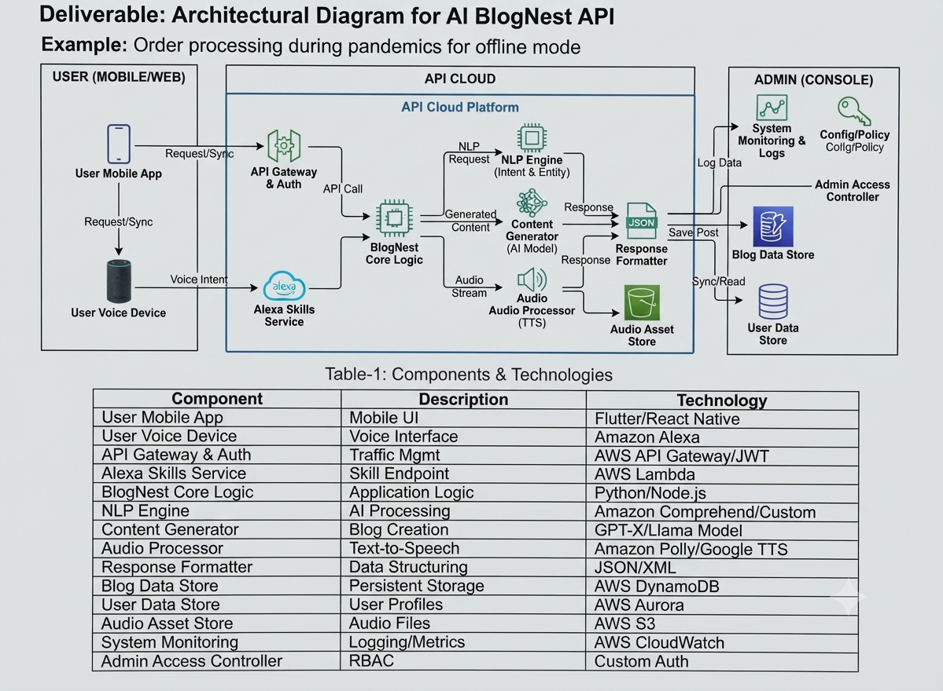

Table-2: Application Characteristics:
S.No | Characteristics | Description | Technology
 | Open-Source Frameworks | List the open-source frameworks used | Technology of Opensource framework
 | Security Implementations | List all the security / access controls implemented, use of firewalls etc. | e.g. SHA-256, Encryptions, IAM Controls, OWASP etc.
 | Scalable Architecture | Justify the scalability of architecture (3 – tier, Micro-services) | Technology used
 | Availability | Justify the availability of application (e.g. use of load balancers, distributed servers etc.) | Technology used
 | Performance | Design consideration for the performance of the application (number of requests per sec, use of Cache, use of CDN’s) etc. | Technology used

